Encrypted package for ssh

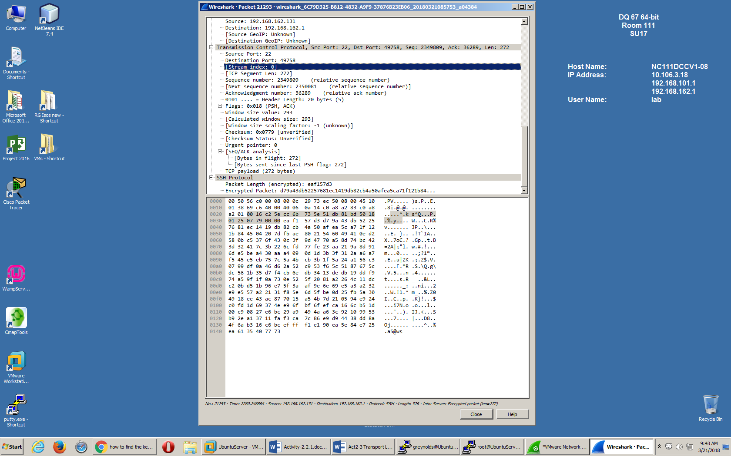

DHCP REQUEST

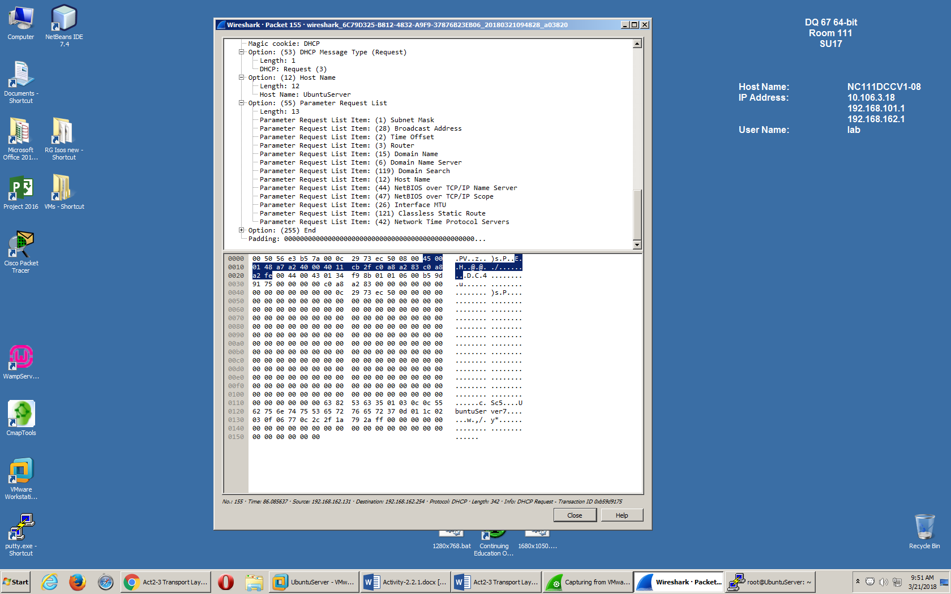

Closed SSH connection

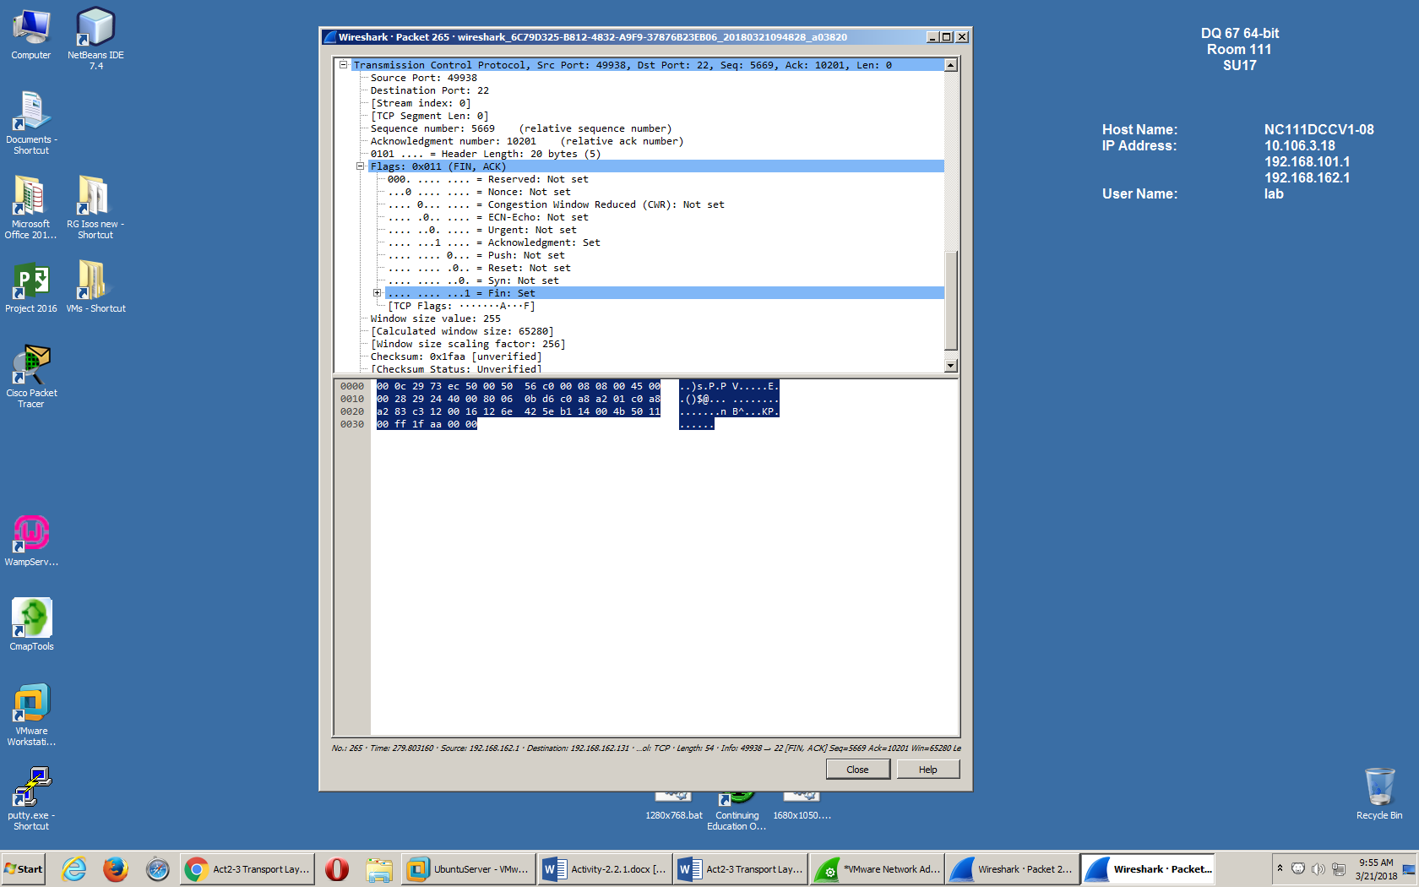

Using apache2 on the Ubuntu Server to connect to the testing page for apache. 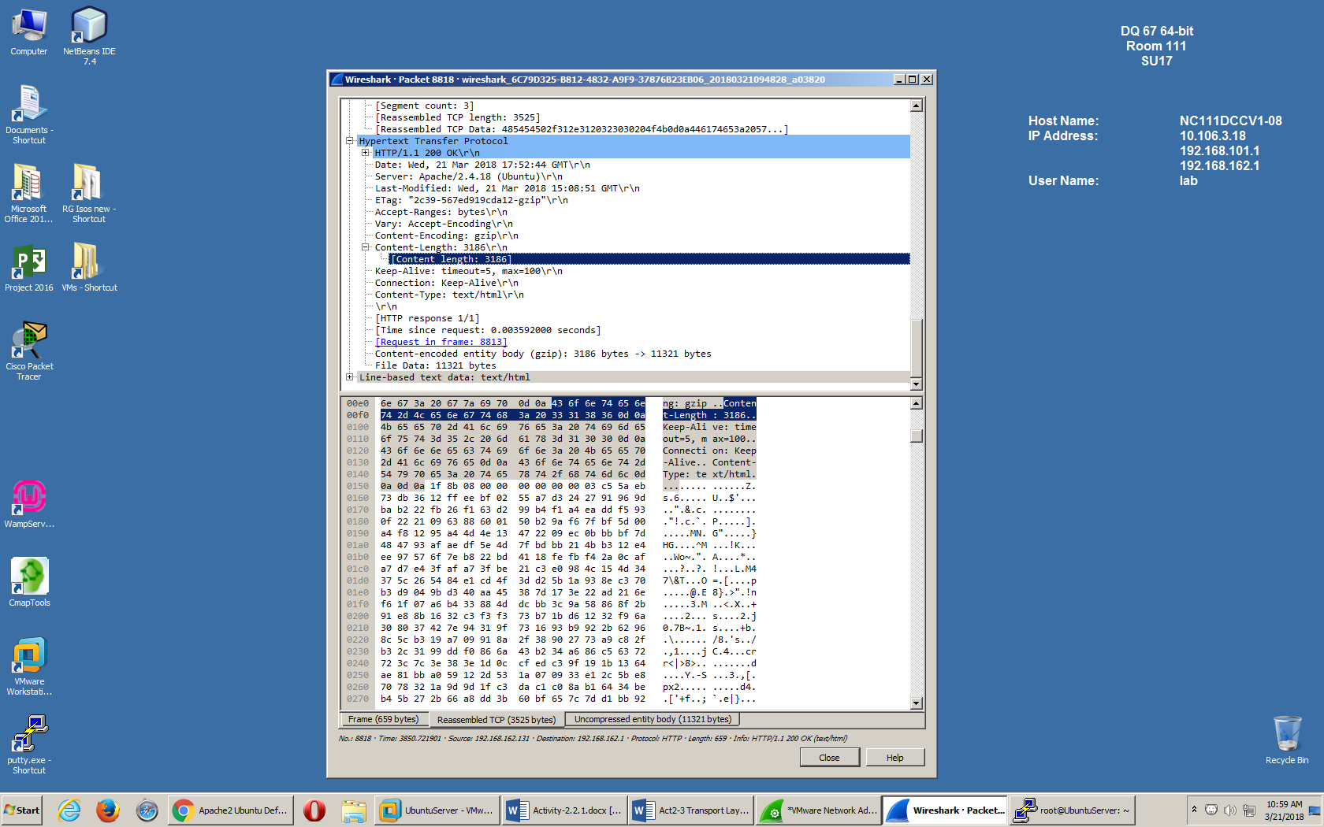

Using elinks on the Ubuntu Server to connect from the server using a text mode web browser

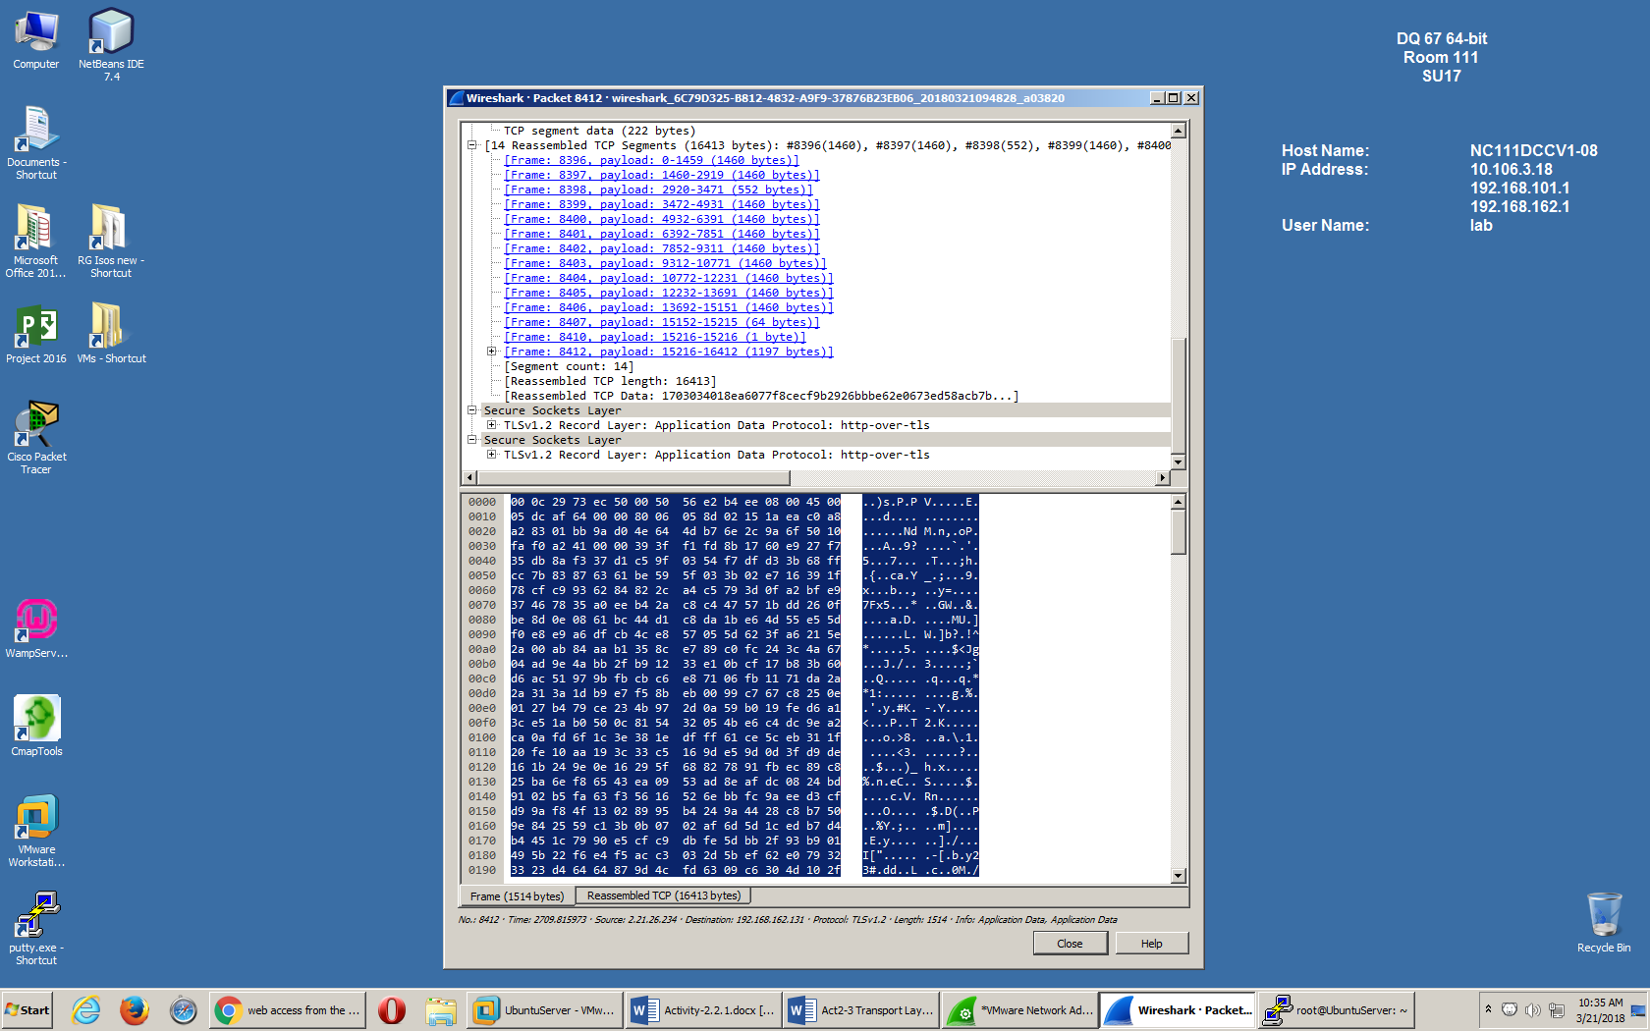

Client Ack request for ssh

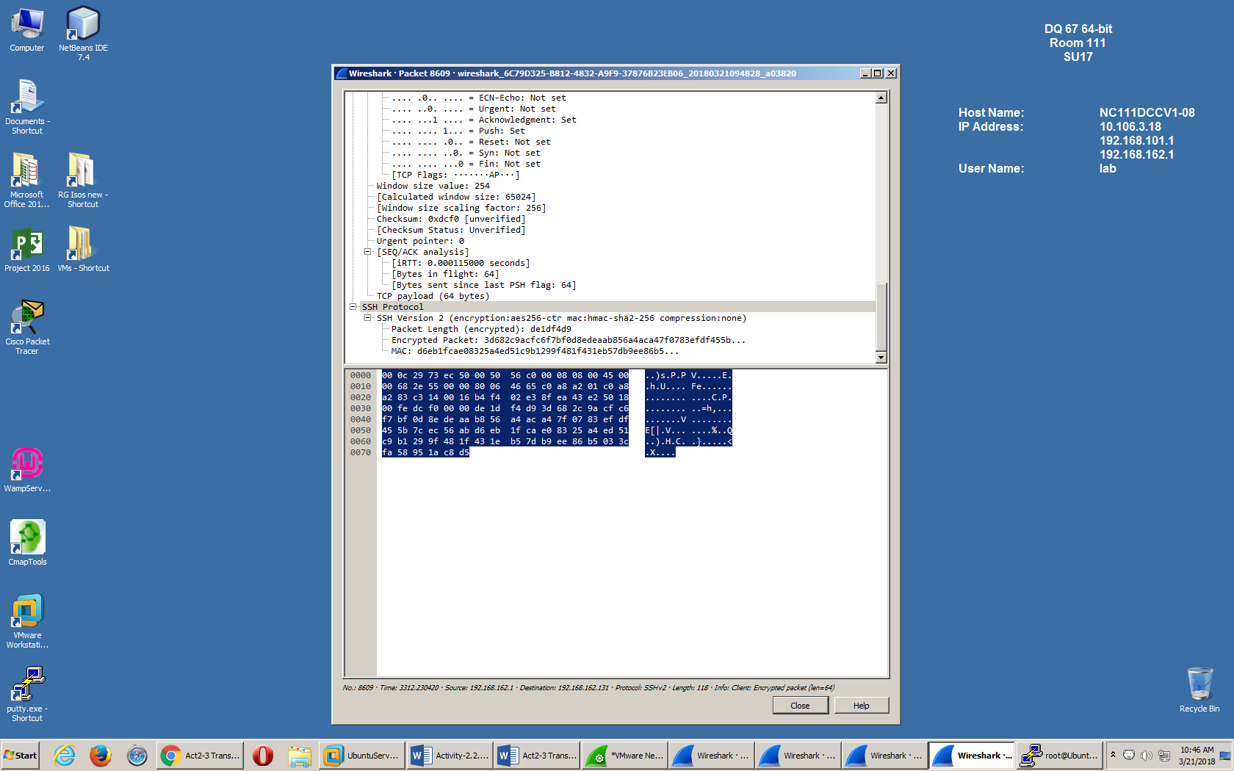

IMCP request requests to google.com

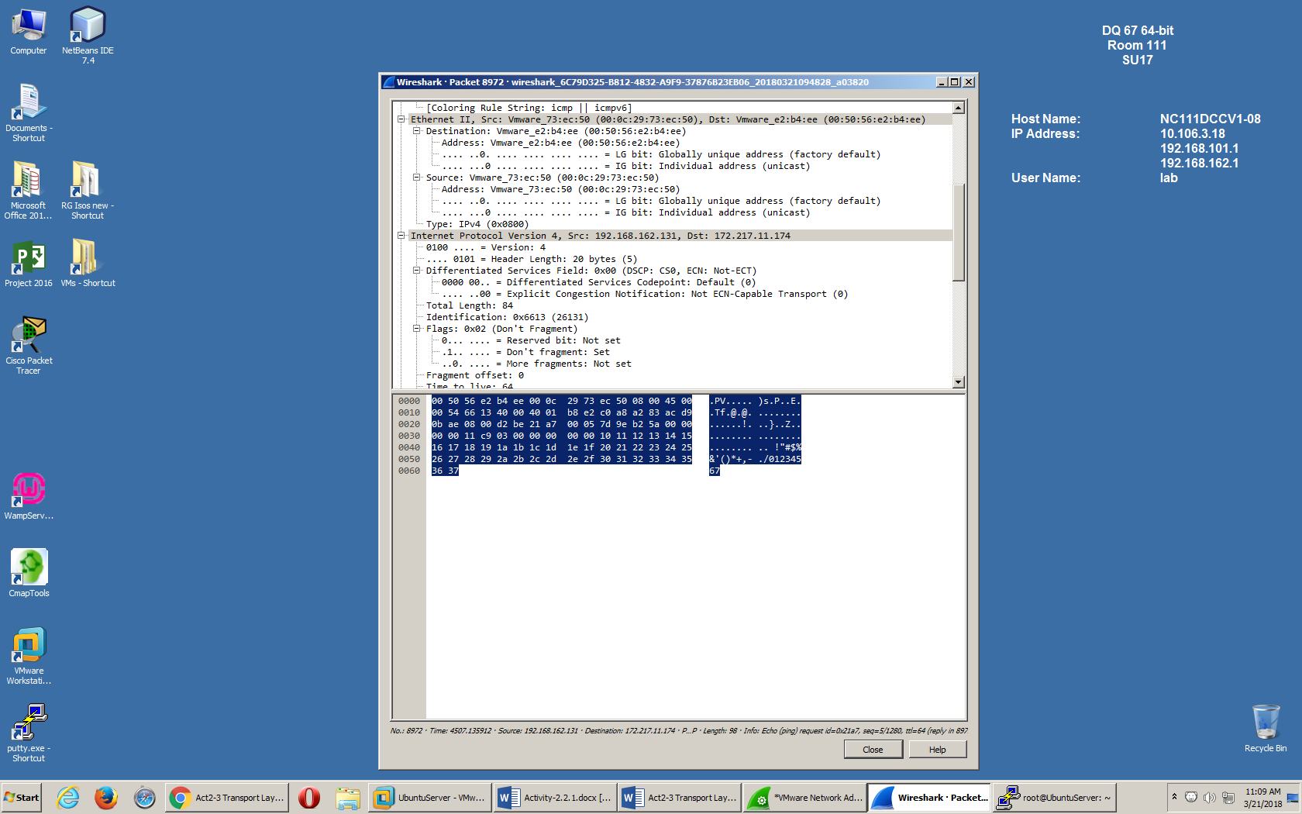

ICMP reply from google.com

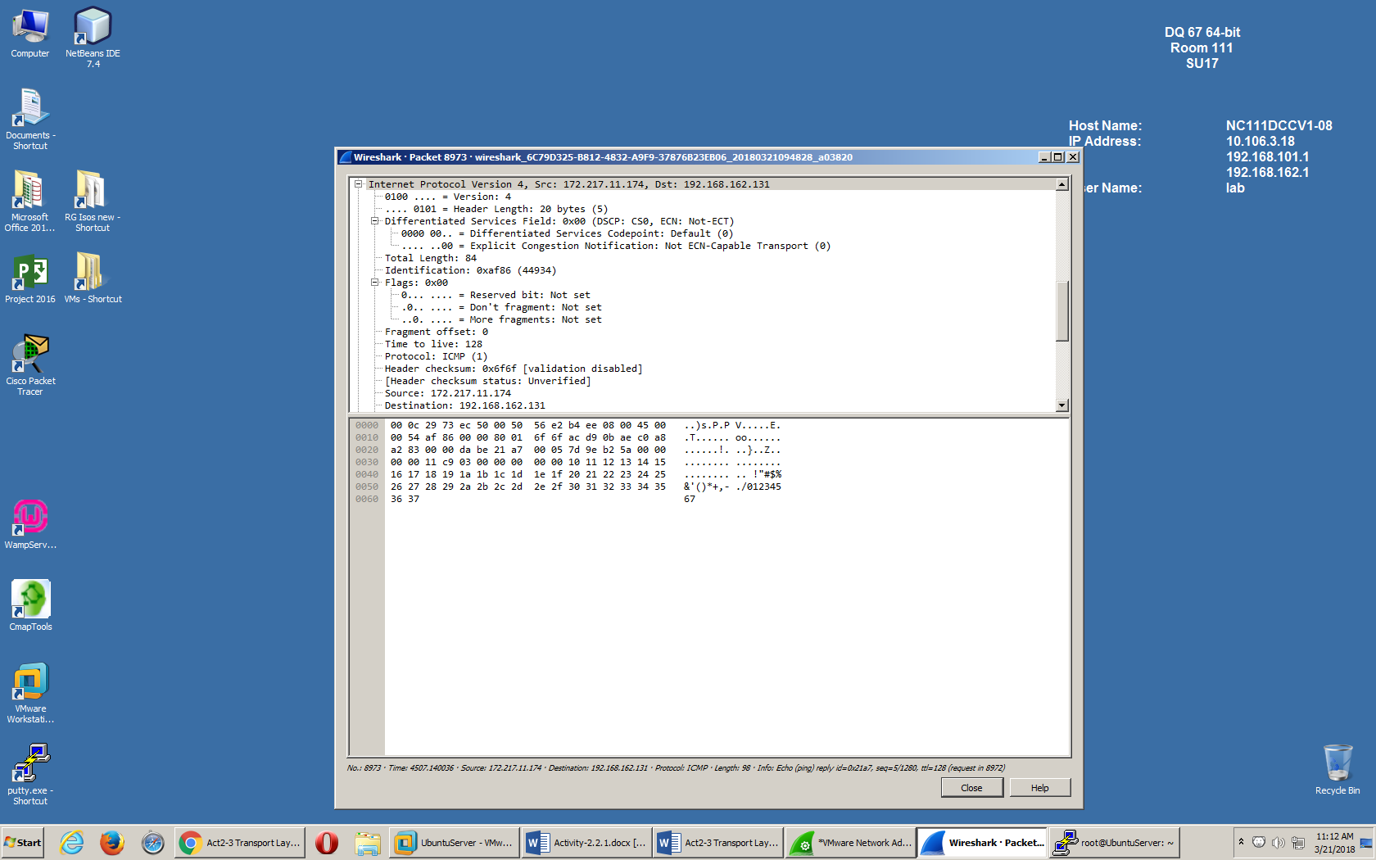

ICMP Pings from the gateway.

